**Threatened Organisms**

Your task is to:

Select **ONE** organism from the list of threatened species in Australia, and find out the following:

* Its normal habitat
  + A picture/ map of its habitat and where it is in Australia
  + Describe the habitat (what plants/ animals live there, is it hot, cold, wet, sunny?)
* The changes occurring that are causing the numbers of this organism to decrease
  + What changes are occurring? (deforestation, global warming etc.)
  + How are the population numbers changing? (Show numbers of how many were there before and how many are left)
* The influence of human activity on these changes
  + What are humans doing? Why is it bad for the organism?
* Propose (create/ think of) actions that could be taken to conserve (protect) this organism

Present your research on an A3 poster. You must make it visually appealing as it will be hung up in the science classroom. It should have lots of colours, pictures/ maps, a clear layout, neat writing and correct spelling. Use full sentences.

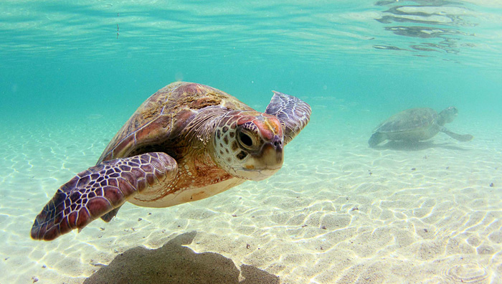

|  |  |
| --- | --- |
| **Information** | **Marks** |
| Habitat |  |
| The threatened organism (plant or animal) is in Australia | 1 |
| States or has a diagram showing its location in Australia | 1 |
| Type of habitat stated and described | 2 |
| Changes |  |
| Type of change | 1 |
| States how the numbers of the organisms have changed over time  Now (1) before (1) | 2 |
| Human impact |  |
| State if human activity has influenced population | 1 |
| Conservation |  |
| List at least 2 strategies for conserving the organism | 2 |

|  |  |
| --- | --- |
| **Presentation** | **Marks** |
| Use of colour and pictures for visual appeal | 2 |
| Clear layout and presentation of material | 1 |
| Appropriate language (in own words, scientific language) | 2 |
| High level of detail | 2 |
| Correct spelling and grammar | 1 |
| Bibliography |  |
| At least 3 references | 1 |
| In consistent and correct formatting | 1 |

|  |  |
| --- | --- |
| **Total** | 20 |
|  |  |

Comment:

________________________________________________________________________________________________________________________________________________________________________________________________________________________________________________________________________________________________________________________________________

Optional

Student peer assess – gallery walk

|  |  |  |
| --- | --- | --- |
| Organism: Class:  Student: | | |
| Structure and presentation | 10 | Is the poster attractive? Does it make good use of colours and/or pictures? Is the information well structured? |
| Interest | 5 | Is the poster likely to interest the audience of the class? Is the language appropriate for this audience? Does it contain new interesting information? |
| Relevance | 5 | Is the material relevant to the topic? Is any significant part of the topic not covered? |
| Accuracy | 5 | Is the information true? |
| Level of detail | 5 | Is there too much information? Is there too little? |
| Total |  | |
| Optional comment |  | |